Revenue Management and Pricing Analytics
Hedonic Pricing, Demand Estimation and RevPAR Optimisation in Python

Week 5 Task | Hotel Booking Demand Dataset

Prepared by: Abhishek Pal
Computer Science Engineering (Data Science), ABES Engineering College
September 2026

1. Problem Framing
Revenue management is the practice of selling the right room to the right guest at the right price and time, to maximise revenue from a fixed number of rooms. The core metrics are:
Metric | Definition | Role
ADR (Average Daily Rate) | Room revenue divided by rooms sold | Price level
Occupancy Rate | Rooms sold divided by rooms available | Demand level relative to capacity
RevPAR (Revenue per Available Room) | ADR x Occupancy Rate (equivalently, room revenue / rooms available) | Combined price-and-volume performance measure, the main revenue management KPI

The central challenge is that ADR and demand are not independent: raising price can reduce the number of rooms sold, so the pricing question is really 'what price maximises RevPAR', not 'what price maximises ADR'. Answering it requires knowing how demand responds to price (elasticity) while separating that response from seasonal and day-of-week effects that move price and demand together for other reasons. This report addresses three questions: (1) what characteristics of a booking and the calendar predict price (a hedonic pricing model); (2) can a demand-price elasticity be estimated from historical booking data, and what goes wrong when this is attempted naively; (3) what would RevPAR-maximising pricing look like under reasonable demand assumptions, and how do the two hotels compare as competing properties.

2. Data Selection
The same cleaned Hotel Booking Demand dataset used in Weeks 1-3 is used here (87,221 bookings, 63,213 of them not cancelled, City Hotel and Resort Hotel, 2015-2017). It contains genuine historical ADR, arrival dates and market segment for every booking, which is what this task needs; no simulation was required.

2.1 Deriving occupancy and RevPAR
The dataset has no room-capacity or occupancy field, so occupancy had to be constructed. Bookings (excluding cancellations) were grouped by hotel and arrival date to get daily arrival counts and average ADR. A capacity was then assumed per hotel, set near the 99th percentile of its observed daily arrivals, rounded:
Hotel | Assumed daily capacity (rooms) | Basis
City Hotel | 90 | 99th-percentile daily arrivals (90.1), rounded
Resort Hotel | 65 | 99th-percentile daily arrivals (65.2), rounded

Occupancy = daily arrivals / assumed capacity (capped at 100%), and RevPAR = ADR x occupancy. This is an explicit, stated assumption, not a measured figure: real capacity is unknown, and arrivals are used as a proxy for rooms occupied that night, which ignores stays that span several nights and were not new arrivals that day. All occupancy and RevPAR figures in this report should be read as an illustrative proxy, consistent in direction but not in absolute level with a real property's numbers.
Hotel | Mean ADR | Mean occupancy (proxy) | Mean RevPAR (proxy)
City Hotel | 103.01 | 52.4% | 56.95
Resort Hotel | 91.95 | 50.3% | 46.8

3. Pricing Trends and Seasonality
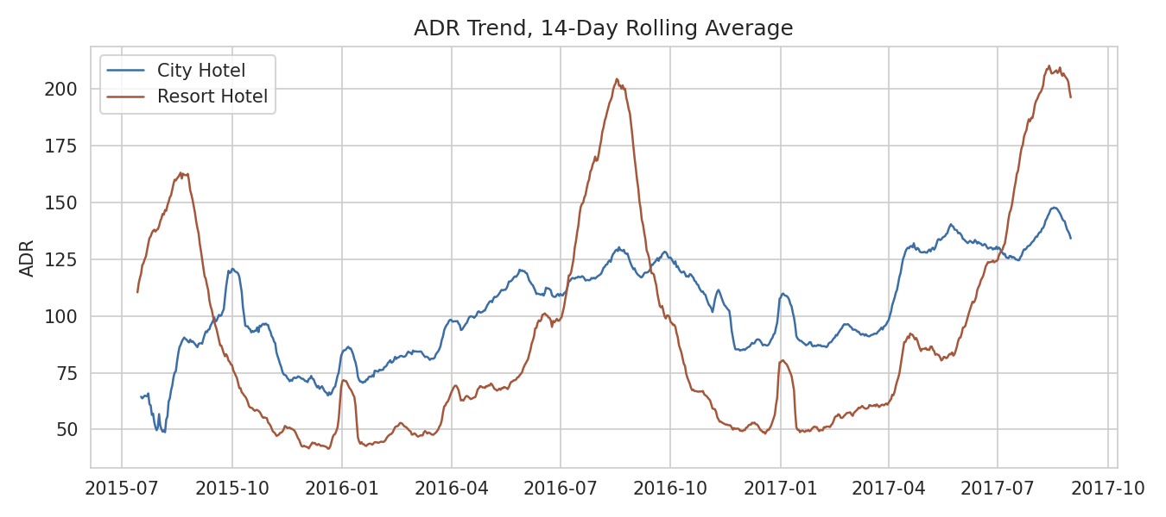
Figure 1. 14-day rolling average ADR, both hotels.
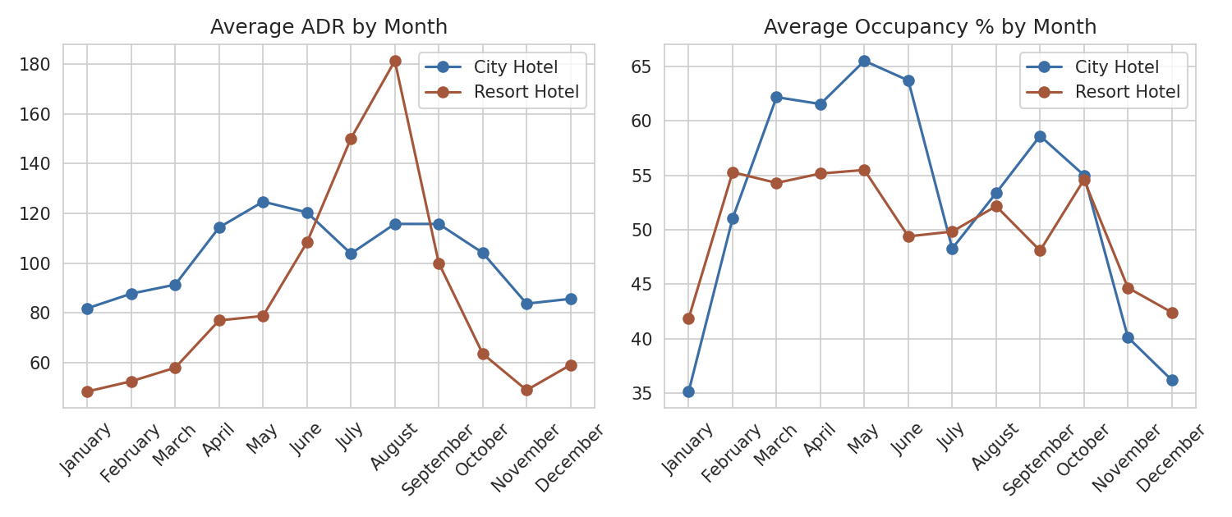
Figure 2. Average ADR and occupancy by month.
The two hotels have almost opposite seasonal patterns. City Hotel ADR peaks in spring (April-May, around 113-124) with a secondary softening in mid-summer, consistent with business and city-break travel. Resort Hotel ADR peaks sharply in August (around 180, roughly double its winter rate), consistent with beach-holiday seasonality. City Hotel occupancy is highest in spring and autumn and dips in winter and high summer; Resort Hotel occupancy tracks its price much more closely, rising into the summer peak.
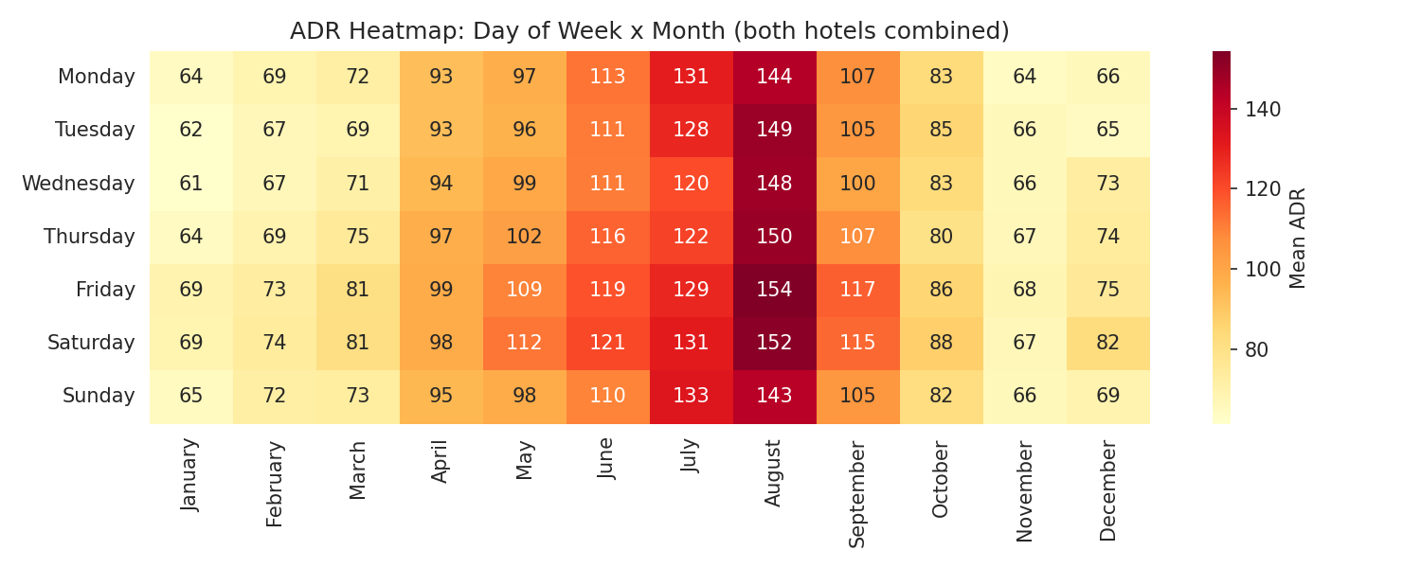
Figure 3. ADR by day of week and month (both hotels combined).
Hotel | Weekday ADR | Weekend ADR | Weekend premium
City Hotel | 102.58 | 104.08 | 1.5%
Resort Hotel | 91.01 | 94.3 | 3.6%

Weekend pricing is only slightly higher than weekday pricing at both hotels (1.5% and 3.6%), and the heatmap shows the month effect (a swing of more than 80 in mean ADR from January to August) dwarfs the day-of-week effect. This is itself an actionable observation: the data suggests seasonal pricing is doing most of the work here and weekday/weekend pricing is comparatively flat, which may be leaving revenue on the table on high-demand weekends within shoulder months.

4. What Predicts Price: A Hedonic Pricing Model
A hedonic regression explains price as a function of the characteristics of what is being sold. Here, log(ADR) is regressed on booking and calendar characteristics using ordinary least squares (OLS) with heteroskedasticity-robust standard errors, on a random sample of 40,000 non-cancelled bookings for computational speed.
formula = ('log_adr ~ log_lead + total_nights + total_guests + has_children'
' + C(hotel) + C(month) + C(market_segment)'
' + weekend_share + total_of_special_requests')
model = smf.ols(formula, data=sample).fit(cov_type='HC1')

The model explains R-squared = 0.431 (adjusted 0.431) of the variation in log(ADR) on 40,000 bookings — a moderate fit, expected since ADR also reflects unobserved factors like exact room type and real-time demand.

4.1 Key coefficients
Variable | Coefficient (log points) | Approx. % effect on ADR | p-value | Interpretation
log(lead time) | -0.002 | -0.2% | 0.464 | Not significant: booking early or late has little independent effect on price once season is controlled
Total nights | 0.024 | 2.4%/night | < 0.001 | Each extra night is priced about 2.4% higher on average
Total guests | 0.229 | 22.9%/guest | < 0.001 | Larger parties pay more per night, consistent with bigger rooms or extra-guest charges
Has children | -0.050 | -5.0% | 0.001 | Family bookings are modestly cheaper per night controlling for guest count and nights
Weekend share of stay | 0.093 | 9.3% | < 0.001 | A stay made up entirely of weekend nights costs about 9.8% more than an all-weekday stay
Special requests | 0.028 | 2.8%/request | < 0.001 | More requests associate with higher-rate bookings (likely higher room categories)
Resort vs. City Hotel | -0.277 | -27.7% | < 0.001 | Resort Hotel prices about 24% lower than City Hotel after controlling for month, stay length and segment

4.2 Month effect (vs. January), controlling for other factors
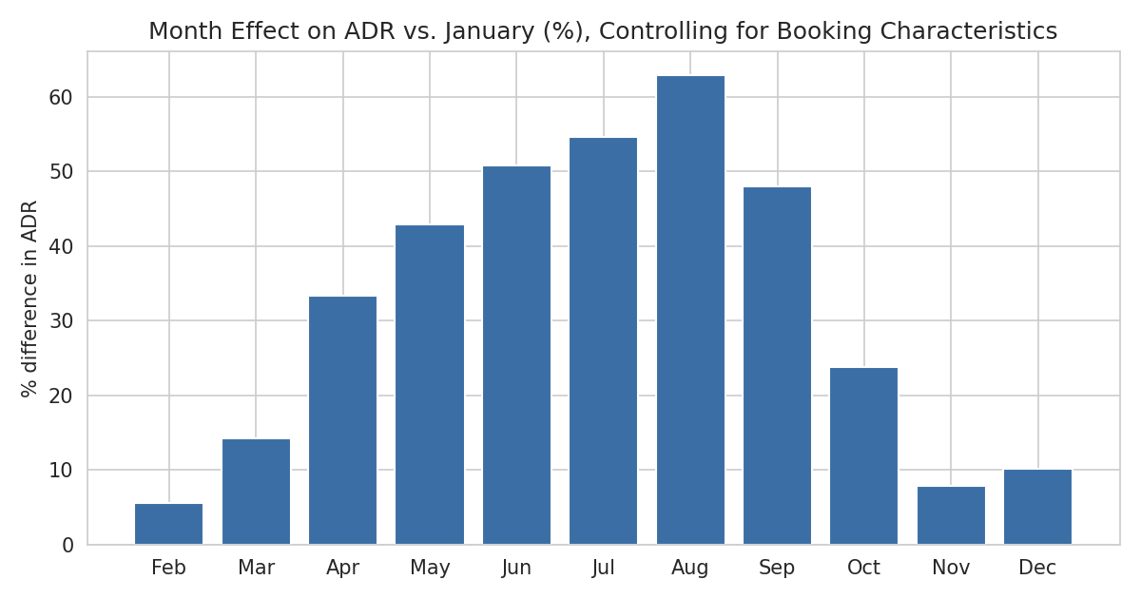
Figure 4. Estimated month effect on ADR, holding booking characteristics constant.
Even after controlling for length of stay, party size and market segment, August commands a 62.9% premium over January, and the ordering June-September is the most expensive stretch. This confirms the seasonality in Figure 2 is a genuine price effect, not just a composition effect (e.g., more families or longer stays in summer).

4.3 Market segment effect (vs. Aviation, the omitted baseline)
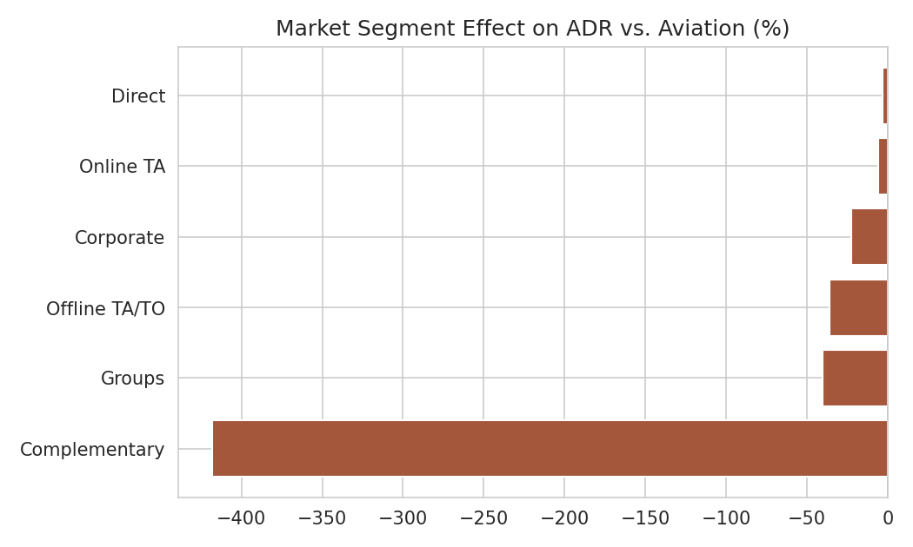
Figure 5. Estimated market-segment effect on ADR.
Direct and Online TA bookings sit closest to the baseline; Complementary bookings are priced dramatically lower (as expected, since these are free or heavily discounted stays); Groups and Offline TA/TO bookings carry a 40-36% discount, consistent with negotiated wholesale rates.

5. Estimating Price Elasticity of Demand
Price elasticity of demand measures how many percent bookings change for a 1% change in price. It is normally estimated by regressing log(quantity) on log(price). This section applies that standard method to the daily hotel-level panel and shows why the result cannot be trusted at face value here — an important, and common, pitfall in pricing analytics with observational data.
daily['log_bookings'] = np.log(daily.bookings)
daily['log_adr'] = np.log(daily.adr)

naive = smf.ols('log_bookings ~ log_adr', data=daily).fit(cov_type='HC1')
controlled = smf.ols('log_bookings ~ log_adr + C(month) + C(dow) + C(hotel)',
data=daily).fit(cov_type='HC1')

Model | Elasticity coefficient | p-value | R-squared
Naive (price only) | 0.483 | 0.000 | 0.153
Controlled (+ month, day-of-week, hotel) | 0.562 | 0.000 | 0.308
Within month x hotel (deviations from group mean) | 0.24 (raw slope, not log-log) | 0.000 | -

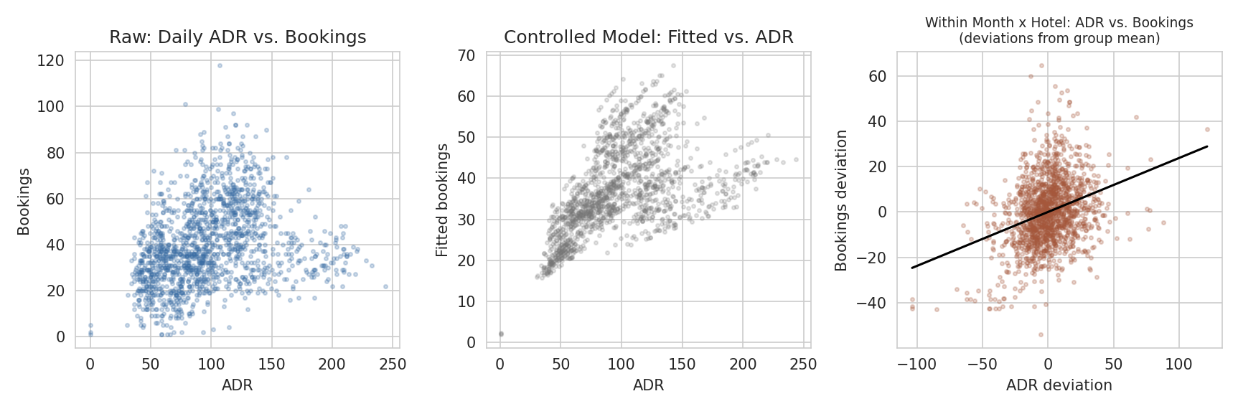
Figure 6. Left: raw ADR vs. bookings. Right: within-month-and-hotel deviations still move together, not apart.

5.1 Why the coefficient is positive, and what that means
A genuine demand curve should show a negative coefficient: higher price, fewer bookings. Every version here is positive and highly significant (p < 0.001) — even after removing month, weekday and hotel effects, days with above-average ADR still have above-average bookings. This is the classic simultaneity (reverse-causality) problem in observational pricing data: a hotel's own revenue-management system raises ADR when it expects high demand and lowers it when it expects low demand, so price is partly a consequence of anticipated demand, not only a cause of realised demand. Historical (price, quantity) pairs collected this way trace out the hotel's own pricing *reaction* to demand, not the underlying demand curve. This cannot be fixed by adding more controls to this dataset; it requires either exogenous price variation (e.g., a controlled pricing experiment or an instrumental variable uncorrelated with demand) or a structural model, neither of which is available here.
This is a genuine finding, not a dead end: it shows precisely why naive historical regressions should not be used to set prices, and it is the reason Section 6 uses assumed, literature-informed elasticities for the optimisation exercise rather than the coefficient estimated above.

6. Illustrative RevPAR Optimisation
Because a causal elasticity cannot be identified from this data (Section 5.1), this section demonstrates the optimisation method under three assumed elasticity scenarios spanning the range typically cited for hotel demand: inelastic (loyal or corporate-heavy demand, -0.5), moderate/near-unit-elastic (-1.0), and elastic (price-sensitive leisure demand, -1.8). These are what-if assumptions, not estimates from the data, and are clearly presented as such.
def price_scenario(hotel, elasticity):
base_adr, base_bookings = daily_mean_adr, daily_mean_bookings
for pct_change in range(-40, 61, 2):
new_adr = base_adr * (1 + pct_change/100)
new_bookings = base_bookings * (1 + pct_change/100) ** elasticity
new_occ = min(new_bookings / capacity, 1.0)
revpar = new_adr * new_occ

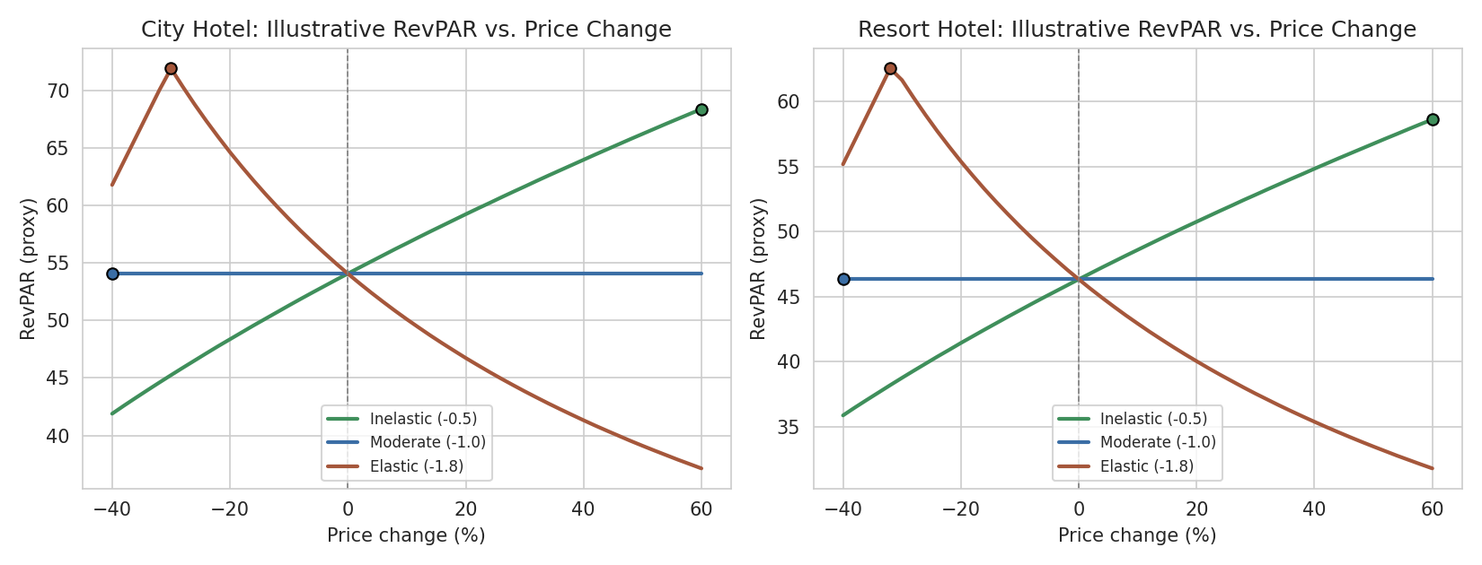
Figure 7. Simulated RevPAR against price change, under three assumed elasticities.

6.1 City Hotel
Demand assumption | Optimal price change | Resulting ADR | Resulting occupancy | Resulting RevPAR | RevPAR vs. current
Inelastic (-0.5) | 60% | 164.8 | 41.5% | 68.41 | +26.5%
Moderate (-1.0) | -40% | 61.8 | 87.5% | 54.08 | +0%
Elastic (-1.8) | -30% | 72.1 | 99.8% | 71.94 | +33%

6.2 Resort Hotel
Demand assumption | Optimal price change | Resulting ADR | Resulting occupancy | Resulting RevPAR | RevPAR vs. current
Inelastic (-0.5) | 60% | 147.1 | 39.8% | 58.61 | +26.5%
Moderate (-1.0) | -40% | 55.2 | 84% | 46.34 | +0%
Elastic (-1.8) | -32% | 62.5 | 100% | 62.53 | +34.9%

Reading the pattern: under inelastic demand, RevPAR keeps rising as price rises across the whole tested range (occupancy still has headroom below the assumed capacity), so the model wants to push price up until capacity binds - a reminder that these are corner solutions of the range tested, not proof that a 60% increase is sensible. Under near-unit elasticity, RevPAR is essentially flat with price, which is the textbook property of unit elasticity (price and quantity changes offset exactly). Under elastic demand, RevPAR is maximised by cutting price toward the point where occupancy approaches capacity, after which further discounting only gives away revenue. The practical lesson is not a specific number, but the shape: knowing which regime a hotel's true demand sits in changes the pricing decision from 'raise price' to 'hold' to 'cut price', which is exactly why estimating a credible elasticity (Section 5) matters so much in practice.

7. Cancellation Risk Across Price Bands
List price is not realised revenue if the booking cancels. Bookings were split into five equal-sized ADR bands (quintiles) and cancellation rate was compared.
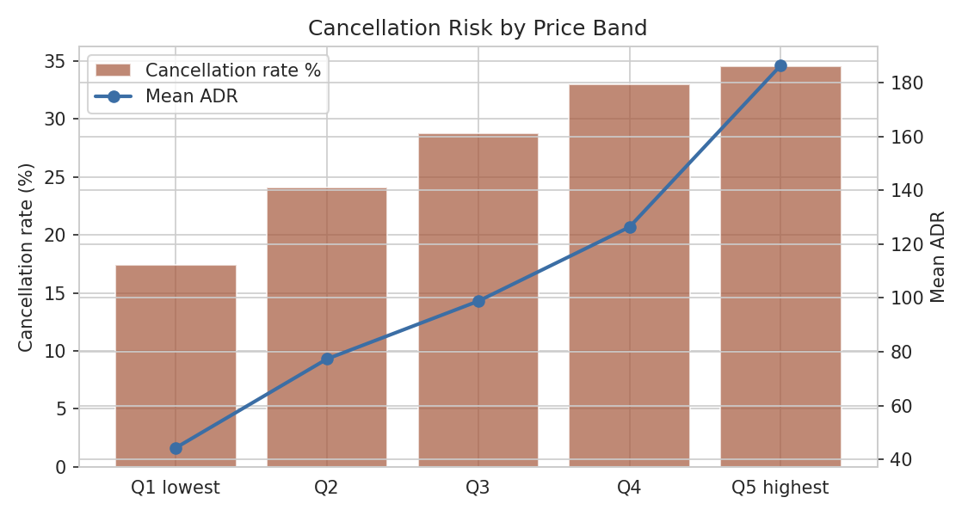
Figure 8. Cancellation rate and mean ADR by price quintile.
Price band | Mean ADR | Cancellation rate | Bookings-weighted revenue index (Q1 = 100)
Q1 lowest | 44.3 | 17.4% | 100
Q2 | 77.4 | 24.1% | 160.4
Q3 | 98.8 | 28.8% | 192.3
Q4 | 126.4 | 32.9% | 231.4
Q5 highest | 186.4 | 34.5% | 333.4

Cancellation rate rises steadily with price, from 17.4% in the cheapest band to 34.5% in the most expensive band. This means expected (cancellation-adjusted) revenue grows more slowly than list price across bands, and any pricing strategy that pushes rates up without also tightening deposit or cancellation policy at the high end will realise less of the apparent gain than the sticker price suggests.

8. Competitive Benchmark: City Hotel vs. Resort Hotel
With only two properties in the data, each is used as a competitive benchmark for the other - a small but real illustration of comparative rate positioning.
Metric | City Hotel | Resort Hotel
Mean ADR | 108.64 | 93.01
Mean length of stay (nights) | 2.98 | 4.2
Mean party size | 1.98 | 1.98
Mean lead time (days) | 67.52 | 74.02
Cancellation rate | 30.1% | 23.5%

8.1 Rate by distribution channel
Channel | City Hotel ADR | Resort Hotel ADR | City share of bookings | Resort share of bookings
Direct | 120.8 | 110.2 | 12.4% | 20.9%
Online TA | 118.5 | 107.5 | 59.9% | 42.3%
Offline TA/TO | 86 | 74.3 | 16.1% | 22.4%
Corporate | 82.1 | 49.6 | 5.3% | 6.7%
Groups | 86.1 | 64.2 | 4.7% | 7.1%

City Hotel earns a higher ADR across almost every channel and relies more heavily on Online TA (59.9% of bookings) than Resort Hotel. Direct bookings command the best rate at both properties, reinforcing that shifting share toward the direct channel is a rate-accretive (and commission-saving) lever independent of any headline price change.

9. Strengths and Limitations of the Approach
Aspect | Strength | Limitation
Hedonic pricing model | Genuine ADR data, robust standard errors, R-squared 0.43 is reasonable for price data with unobserved room-level detail | Correlational, not causal; omits real-time demand, competitor pricing and room-type detail
Demand elasticity | Standard, correctly specified log-log method; controlled and within-group versions both tested | Reverse causality (Section 5.1) means the sign and size cannot be used directly for pricing; this is a data limitation, not a modelling error
RevPAR optimisation | Transparent formula, three elasticity scenarios shown so the sensitivity of the 'optimal' price to the assumption is visible | Assumed, not estimated, elasticities; ignores competitor response, brand effects and diminishing capacity-constrained returns beyond the tested range
Occupancy/RevPAR proxy | Makes cancellation-adjusted, capacity-relative metrics possible from booking-only data | Capacity is assumed, not observed; arrivals are used as a stand-in for rooms occupied that night, which understates multi-night stays' true daily occupancy
Competitive benchmark | Two real hotels with different demand profiles (business vs. leisure) is illustrative | Only two properties, one country, one time window; not a full competitive set

10. Strategic Pricing Recommendations
- Lean on the calendar, not the weekday: the hedonic model shows month effects of up to 63% (August vs. January) while weekend premiums are only 1.5-3.6%. Review whether weekend rates in shoulder months (April-June, September-October) are high enough relative to weekday rates in the same months.
- Treat Resort Hotel's peak (August) and City Hotel's peaks (spring, early autumn) as separate revenue-management calendars rather than a single hotel-wide seasonal policy, since their patterns are close to opposite.
- Grow the Direct channel: it carries the best rate at both properties and avoids intermediary commission; consider incentives (loyalty pricing, free cancellation) to shift share away from Offline TA/TO and Groups, which carry the largest discounts.
- Before committing to any price increase, estimate a defensible elasticity - ideally from a controlled pricing test (holding a small set of dates or a rate code as a randomised control) or an instrumental-variable approach - because the historical regression in this data cannot supply one.
- Tighten deposit or cancellation terms at higher price bands: cancellation rate rises from 17% to 35% across ADR quintiles, so premium-rate strategies should be paired with policy changes that protect realised RevPAR, not list price.
- Use the RevPAR-optimisation method in Section 6 operationally once a credible elasticity is available; until then, treat any 'optimal price' figure from this kind of model as illustrative only.

11. Conclusion
This analysis built occupancy and RevPAR proxies from real booking data, fitted a hedonic pricing model that explains 43% of ADR variation from booking and calendar characteristics, and attempted to estimate price elasticity of demand. The elasticity exercise produced an important negative result: naive and even seasonally controlled regressions on historical pricing data give an economically implausible positive coefficient, a textbook case of reverse causality between a revenue-management system's price decisions and the demand those decisions were made in response to. Rather than present that number as an answer, the report used it as an occasion to demonstrate correct practice: state the assumption explicitly, run the optimisation under a range of literature-informed elasticities, and be explicit about which parts of the analysis are estimated from data (seasonality, segment premiums, cancellation risk by price band) versus assumed for illustration (the demand elasticity and resulting optimal price). The concrete, data-grounded findings - strong and differing seasonality between the two hotels, a Direct-channel rate premium, and rising cancellation risk at higher price points - are actionable regardless of the elasticity question and form the basis of the recommendations above.

References
Antonio, N., de Almeida, A., & Nunes, L. (2019). Hotel booking demand datasets. Data in Brief, 22, 41-49.
Cross, R. G., Higbie, J. A., & Cross, D. Q. (2009). Revenue management's renaissance: A rebirth of the art and science of profitable revenue generation. Cornell Hospitality Quarterly, 50(1), 56-81.
Kimes, S. E. (2011). Customer-based revenue management: Setting rates based on customer response to price. Cornell Hospitality Report, 11(2).
Seabold, S., & Perktold, J. (2010). statsmodels: Econometric and statistical modeling with Python. Proceedings of the 9th Python in Science Conference.
Wooldridge, J. M. (2010). Econometric Analysis of Cross Section and Panel Data (2nd ed.). MIT Press. (Simultaneity and endogeneity in price-quantity regressions)

